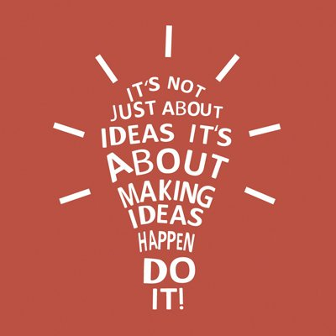 | Opportunities for teaching Diversity, Equality & Cultural Capital:  Visit the old Skinningrove mine at Loftus. Visit the Sirius mine.  DT Knowledge Organiser – Pulleys & Levers  Upper KS2: Year 5 |  | Recall and Remember:  What are the key parts of a lever?  What is the main purpose of a lever?  Can you describe the 3 classes of lever?  What are the key elements of a pulley?  What is the main purpose of a pulley?  Can you describe the 3 types of pulleys?
Key Knowledge about Pulleys  A pulley is a wheel on an axle designed to support movement or change the direction of a force using a cable along its circumference. Pulleys are used in a variety of ways to lift loads, apply forces, and to transmit power. The drive element of a pulley system can be a rope, cable, belt, or chain that runs over the pulley inside the groove.  There are different types of pulley systems:  A fixed pulley has a fixed axle, it is used to change the direction of the force on a rope/belt. A fixed pulley has equal force on both sides of the pulley and there is no multiplication of force.  A movable pulley has a free axle - the axle can move in space. Pulling on one end of the rope will apply a doubled force to the object attached to the pulley.  A compound pulley, which is a combination of pulley systems. |  | What you will have learnt by the end of this unit.  - To use prototypes and pattern pieces to communicate their ideas  - To select from a wide range of tools and materials based on their aesthetic qualities  - To investigate and analyse a range of existing products  What you have already learnt in Yr4.  - To develop design criteria, based on research, to design functional, appealing products aimed at individuals or groups  - To select from a wide range of tools and materials to ensure a high-quality finish  - To consider the views of others to evaluate their work and make improvements based on this | Key Knowledge about Levers  A lever can be used to raise a weight or overcome resistance. It consists of a bar, pivoted at a fixed point known as the fulcrum. Extra power can be gained for the same effort if the position of the fulcrum is changed.  Levers can be divided into classes:  First-class levers have the fulcrum in between the applied force and load, which are at opposite ends, such as with the seesaw.  Second-class levers have the fulcrum at one end, and the applied force at the other, such as with a bottle opener.  Third-class levers have the effort in between the fulcrum and the load; for example, tweezers where 2 levers are pressed together to do the work for which they are designed.
Key Designing Skills I will learn/use:
Remember that in order to make a simple machine to work, it is essential that the mechanical system is planned effectively, and includes an input, a process, and an output.

Think:
What is the purpose of your machine?
What will be the input force? How will this be applied?
What system are you going to use to transfer the force?
What do you intend the output to be?

Sketch and annotate different ideas, then plan the main stages of making, using either a checklist, a storyboard, or a flowchart.
Key Building & Evaluating Skills I will learn/use:
Building:
Consider the materials you will need to build your simple machine.
How will you make it fit for purpose?
Do you need a fixed base for your lever or a rigid frame for your pulley system?
How will you ensure each part is attached securely?
How will you ensure all the components move smoothly?
How will you test your simple machine?

Evaluating:
How well does your mechanical system work? Does it move smoothly?
Does it meet its purpose?
What would your audience think about your product? What would they like about it? What would they not like?
What problems did you face in constructing your mechanical system? What changes did you need to make?
What could you still improve about your product? How would you do things differently next time?

Key Vocabulary
Simple Machine | A device that can change the direction or the magnitude of a force, or the point where it is applied. T
Mechanical System | A set of related parts used to create movement
Mechanisms | Devices that transform input forces and movement into a desired set of output forces and movement
Lever | A rigid bar resting on a pivot, used to move a heavy load with one end when pressure is applied to the other.
Fulcrum | The point on which a lever turns or is supported.
Pulley | A grooved wheel over which a drive belt (cable) can run
Drive belt | A cable which connects and transfers movement between the force and the load
Axle | The horizontal shaft that holds a pulley wheel
Rigid | Firmly fixed, stiff
Design | To plan a project to make a new structure or product.
Experiment | Try out new ideas and methods.
Technique | Use a particular method or skill.
Refine | Make changes which improve the structure or function of the final product.
Critique | Express an analysis of the merits and faults of a product
Exhibit | Demonstrate the final product so it can be understood and appreciated by an audience.

My skills and Knowledge that I may use from other subjects
- That force and motion can be transferred through mechanical devices – Science.
- To take and record precise measurements - Maths

What will you have learnt by the end of UKS2.
To come up with a range of ideas or alternative plans after collecting information from different sources.

To produce a detailed, step-by-step plan.

To evaluate the appearance and function against original criteria.

To use a range of tools and equipment competently.

To make a prototype before make a final version.

To suggest improvement to my own work and that of others.

